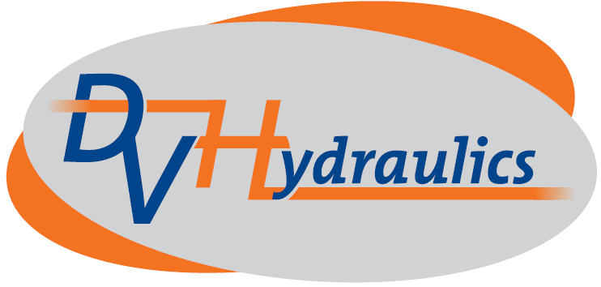 | Atelier : | Hoek 76 – Unit 11 – B-2850 Boom
 | Registered office : | Molenstraat 161 – B-2840 Rumst
 | Tel : | +32 (0)3/888.60.00
 | Fax : | +32 (0)3/888.30.00
 | E-mail : | info@DVHydraulics.be
 | Website : | www.DVHydraulics.be
DV Hydraulics nv

Privacystatement Customers

DV Hydraulics NV processes personal information in compliance with this privacy statement.
For further information, questions or comments on our privacy policy, please contact Hilde Smets at info@dvhydraulics.be

Purposes of the processing
DV Hydraulics NV collects and processes customers’ personal data for customer and order management (customer administration, order/delivery follow-up, invoicing, solvency follow-up, profiling and the sending of marketing and personalised advertising).

Legal foundation for the processing
Personal data is processed based on Article 6.1. [(b) (required for the implementation of an agreement),] [(c) (required to satisfy a legal obligation)], [(f) (required for the protection of our legitimate interest in entrepreneurship)] of the General Data Protection Act.

Transfer to third parties
If required to achieve the set purposes, the customers’ personal data will be shared with a partner of DV Hydraulics NV.
DV Hydraulics NV guarantees that these recipients will take the necessary technical and organisational measures for the protection of personal data.

Retention period
Personal data processed for customer management will be stored for the time necessary to satisfy legal requirements (in terms of bookkeeping, among others).

Right to inspection, improvement, deletion, limitation, objection and transferability of personal data
The customer has at all times the right to inspect their personal data and can have it improved/improve it should it be incorrect or incomplete, have it removed, limit its processing an object to the processing of their personal data based on Article 6.1 (f), including profiling based on said provisions.
Furthermore, the customer is entitled to obtain a copy (in a structured, standard and mechanically readable form) of their personal data and to have said personal data forwarded to another company.
In order to exercise the aforementioned rights, the customer is requested to send an e-mail the following address: info@dvhydraulics.be.

Direct marketing
The customer is entitled to object free of charge to the processing of any processing of their personal data aimed at direct marketing.

Complaint
The customer has the right to file a complaint with the Belgian Privacy Protection Commission (35 Rue de la Presse, 1000 Brussels - commission@privacycommission.be).

